
Information Systems and Data Modeling IT1090
Group Assignment

Title: Luxury Motor Solutions System

Batch Number: 2024 (July) Malabe | Group Number: MLB_04.02_07
Declaration:
We hold a copy of this assignment that we can produce if the original is lost or damaged.
We hereby certify that no part of this assignment has been copied from any other group’s work or from any other source. No part of this assignment has been written / produced for our group by another person except where such collaboration has been authorized by the subject lecturer/tutor concerned.

Group Members:

Student ID | Name | Signature
IT23631410 | B.G.S.H. Dilshara | 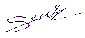
IT23588714 | K.H.S. Dinsara | 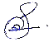
IT23775442 | T.G.C. Theekshana | 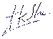
IT23656574 | G.H.C.R. Saumya | 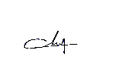
IT23637832 | D.D. Samaranayaka | 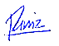

Submitted on: 19/09/2024

